ESSBASE APPLICATIONS AUTOMATION DOCUMENT

CONTENT

1. ARTCHITECTURE
2. APPLICATION AUTOMATION PROCESS
3. NO.OF.JOBS
4. BATCH FLOW

**ARTCHITECTURE**

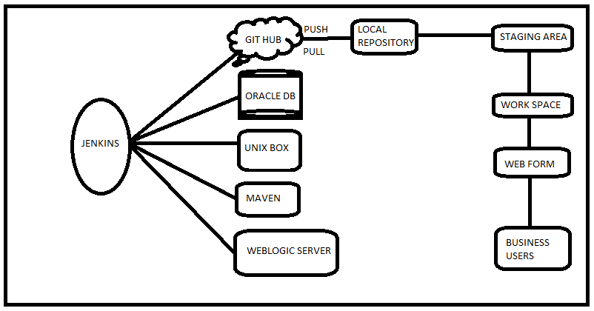

**APPLICATION AUTOMATION PROCESS**

1. Business users can insert, update and delete metadata records as per requirement with help of web forms, then push to the central repository.
2. Jenkins will automatically download the executable file into local machine, then Execute the Oracle Database.
3. Then retrieve the metadata txt files and build to the Essbase applications with the help of UNIX custom scripts and Essbase Scripts.
4. By using maven.. Create .war file and deploy to the application (Web logic)server.

**NO.OF.JOBS**

1. HYP_1001 (control files)
2. HYP_1002(stop/start)
3. Hyp_1003(EBA application Backup)
4. HYP_1004(FINMRT )
5. HYP_1005(BUDGET)
6. HYP_1006(FINREV)
7. HYP_1007(ACTUAL LOAD)
8. HYP_1008(BUDGET LOAD)
9. HYP_1009(DEPOSIT LOAD)
10. HYP_1100(ASSET LOAD)
11. HYP_1101(FINMRPT BACKUP)
12. HYP_1102(BUDGET BACKUP)
13. HYP_1103(FINREV BACKUP)

**BATCH FLOW**

HYP1005

HYP1004

HYP_1002

HYP_1001

HYP_1006

HYP_1007

HYP_1102

HYP_1003

HYP_1101

HYP_1100

HYP_1009

HYP_1103

HYP_1008